About | Calendar | Vote | Volunteer | Learn | Contact | Join | Donate | Login

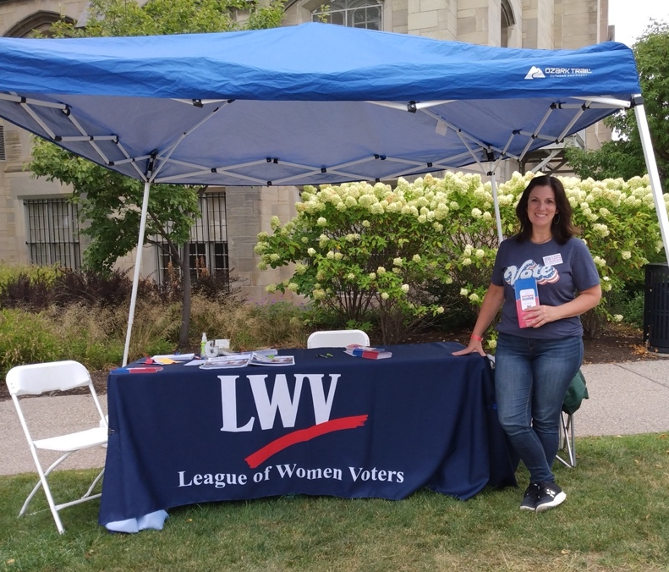
NON-PARTISAN POLICY

Approved Fall 1988; reviewed October 27, 2012
- The League of Women Voters-Rochester Metropolitan Area is a nonpartisan organization which does not support or oppose any political party or candidate. In order to avoid public confusion of an individual’s activities with those of the League, each board member should exercise discretion and refrain from any activities which might make it appear that the League is supporting or opposing a party or candidate.
- It is the responsibility of each individual concerned to inform the board of any political activities being considered, and it is the responsibility of the board to decide when an individual must resign because of such activities.
- It is also the responsibility of the president to remind the nominating committee to discuss the League’s nonpartisanship policy with potential nominees.
- To aid in deciding what activities are appropriate, the following guidelines have been adopted for League board members:
- May not run for partisan public office, may not work publicly for candidates in partisan elections, and may not work publicly for a political party.
- May attend, but may not hostess, coffees or meetings for individual partisan candidates
- May contribute a modest amount to any candidate or party.
- Board members may attend fund raising activities with the exception of the president, vice presidents, the action director, the voters service director.
- May sign petitions for candidates or issues but may not carry a petition for a candidate
- May work as an election inspector but may not be a poll watcher for a candidate.
- If there is a question of whether an action might compromise the nonpartisan policy, consult with the President.
- If a director serves for only part of a year, observation of the nonpartisanship policy is required only for the duration of the time that the director holds that office.
- The political activities of a spouse or family member are considered as separate and distinct from the activities of a League board member.
- A League board member who wishes to actively support a candidate or engage in partisan politics must resign. When such a resignation occurs, care should be taken to be sure that the attendant publicity does not create a partisan impression. Those who have resigned may serve on the board at a future date when no longer involved in political activity.

